**CHAPTER 1**

**INTRODUCTION**

Post office application will help in automating functions of the administration department it help in reducing the time spent in record keeping and work can be carried out easily. The old records can be easily accessed in future.

The project is a web based application for post office management and their customers. It handles all types of transaction details of the post office and their project will reduce the work and most of the work done by computers. It maintains all the old record for later reference and it have provision for automatic update as per the status are the main objectives of this project , post office also help in saving money of customer and do perform the withdraw and e_bill operations through their saving account so that transfer of money is digitalized even we also provided the insurance account and claimed money is passed to the saving accounts

**1.1 PRODUCT PERSPECTIVE AND OBJECTIVE**

This designed product in a follow-on member of an existing database that helps to enhance the existing database and provide wider scope for the database to be used by all the post offices. The burden on the human effort is reduced due to the implementation of this database.

**1.2 Product Function:**

* Store and retrieve the data easily and efficiently.
* Complete details of the customer.
* Securing the data present in the database.
* Handling the data efficiently and accurately
* Retrieving the entire entry using a keyword.

**1.3 AIM AND PERSPECTIVE**

To maintains all the old record for later reference and it can be updated or deleted at any point of time by only through the admins.

**CHAPTER 2**

**SYSTEM REQUIRMENTS SPECIFICATION**

System requirements are the configuration that a system must have in order for a hardware or software application to run smoothly and efficiently. Failure to meet these requirements can result in installation problems or performance problems. The former may prevent a device or application from getting installed, whereas the latter may cause a product to malfunction or perform below expectation or even to hang or crash.

**2.1 HARDWARE REQUIREMENTS**

PROCESSOR : intel® Core(TM) i5

RAM : 2GB minimum

ROM : 300MB minimum

**2.2 SOFTWARE REQUIREMENTS**

Operating system : WINDOWS 10

Programming language : JAVA

Frontend : JAVA frames

Back end : mysql MariaDB

**PRIMARY KEY**

Such type of candidate key which is chosen as a primary key for table is known as primary key. Primary keys are used to identify table there is only one primary key per table.

**FOREIGN KEY**

Foreign key are those keys which is used to define relationship between two tables. When we want to implement relationship between two tables then we use concept of foreign key**.**

**MariaDB**

MariaDB is developed as open source software and as a relational database it provides an SQL interface for accessing data. It is based on the structure query language (SQL), which is used for adding, removing, and modifying information in the database. Standard SQL commands, such as ADD, DROP, INSERT, UPDATE used in MariaDB.

In addition to web usage, MariaDB can be used for stand-alone applications ranging from enterprise transactional and analytics systems down to mobile devices, embedded with other software. MariaDB works in the cloud or on premise.

Many features contribute to MariaDB’s standing as a database system. Its speed is one of its most prominent features. MariaDB is remarkably scalable, and is able to handle tens of thousands of tables and billions of rows of data. It can also manage small amounts of data quickly and smoothly, making it convenient for small business or personal projects.

**JAVA AND JFRAME**

Java is a high-level programming language developed by Sun Microsystems. It was originally designed for developing programs for set-top boxes and handled devices, but later became a popular choice for creating web applications.

The Java syntax is similar to C++, but is strictly an object-oriented programming language. For example, most Java programs contain classes, which are used to define objects, and methods, which are assigned to individual classes. Java is also known for being more strict than C++, meaning variables and functions must be explicitly defined. This means Java source code may produce errors or “exceptions” more easily than other languages, but it also limits other types of errors that may be caused by undefined variables or unassigned types.

JFrame is a class in Java and has its own methods and constructors. Methods are functions that impact the JFrame, such as setting the size or visibility. Constructors are run when the instance is created: One constructor can create a blank JFrame, while another can create it with a default title.

**CHAPTER 3**

**DESIGN AND IMPLEMENTATION**

Database design is the process of producing a detailed data model of database. This data model contains all the needed logical and physical design choices and physical storage parameters needed to generate a design in a data definition language, which can then be used to create a database. A fully attributed data model contains detailed attributes for each entity. The database implementation or deployment is the process **os** installation of database software, configuration and customization, running, testing, integrating with applications, and training the users.

**3.1 ER DIAGRAM**

An entity -relationship model is a systematic way of describing and defining a business process. An ER model id typically implemented as a database. The main component of E-R model are: entity set and relationship set. The ER diagram is show in **fig 3.1**

**3.2 RELATION SCHEMA**

It formulate all the constraints that are to be applied on the data. A database schema defines its entities and the relationship among them.it contains a descriptive detail of the database. It shows how data will be stored in a secondary storage.The RELATION SCHEMA is show in **fig 3.2**

|  |  |  |
| --- | --- | --- |
| USERNAME | **PASSWORD** | **POST_BOX _NUMBER** |

**ADMIN**

**MONEY ORDER**

|  |  |  |  |  |  |  |  |  |  |  |  |  |  |
| --- | --- | --- | --- | --- | --- | --- | --- | --- | --- | --- | --- | --- | --- |
| **PBNO** | SNAME | S_ADD | S_PIN | S_STATE | | S_PHNO | | S_CITY | RNAME | R_ADD | R_PIN | R_STATE | R_CITY |
| R_PHNO | | T_AMOUNT | | AMOUNT | | **M_ID** |

**LETTER OR PARCEL**

|  |  |  |  |  |  |  |  |  |  |  |  |  |  |  |
| --- | --- | --- | --- | --- | --- | --- | --- | --- | --- | --- | --- | --- | --- | --- |
| **PBNO** | CATEGORY | | S_NAME | | S_PIN | | S_ADD | S_PHNO | S_STATE | S_CITY | AMOUNT | | WEIGHT | R_NAME |
| R_ADDRESS **STATUS** | | R_PIN | | R_PHNO | | R_CITY | | R_STATE | | **ID** | |

|  |  |
| --- | --- |
| **ID** | STATUS |

## **ADD ACCOUNT**

|  |  |  |  |  |  |  |  |  |  |  |  |  |
| --- | --- | --- | --- | --- | --- | --- | --- | --- | --- | --- | --- | --- |
| **PBNO** | NAME | ADD | PINCODE | | CITY | STATE | PHNO | DOB | RATION | PANCARD | ADHAR_NO | IFSC_CODE |
| **ACCOUNT_NUMBER**  **ADD MONEY** | | | NOMINEE_ACC_N0 | | |

|  |  |  |
| --- | --- | --- |
| **ACCOUNT_NUMBER** | NAME | AMOUNT |

# **WITHDRAW**

|  |  |  |  |
| --- | --- | --- | --- |
| **ACCOUNT_NUMBER** | NAME | DATE | AMOUNT |

# **CREATE INURANCE**

|  |  |  |  |  |  |  |
| --- | --- | --- | --- | --- | --- | --- |
| **ACCOUNT_NUMBER** | **INSURANCE_ID** | NAME | GENDER | AMOUNT | PANCARD | AGE |

### **CLAIM**

|  |  |  |  |
| --- | --- | --- | --- |
| **INSURANCE_ID** | TIME | DATE | AMOUNT |

**fig 3.2**

**E_BILL**

|  |  |  |  |  |  |  |  |  |
| --- | --- | --- | --- | --- | --- | --- | --- | --- |
| **ACCOUNT_NUMBER** | B_ID | B_NAME | B_ADDRESS | L_USEDUNIT | C_UNIT | AMOUNT | C_DATE | **RECIPT_NO** |

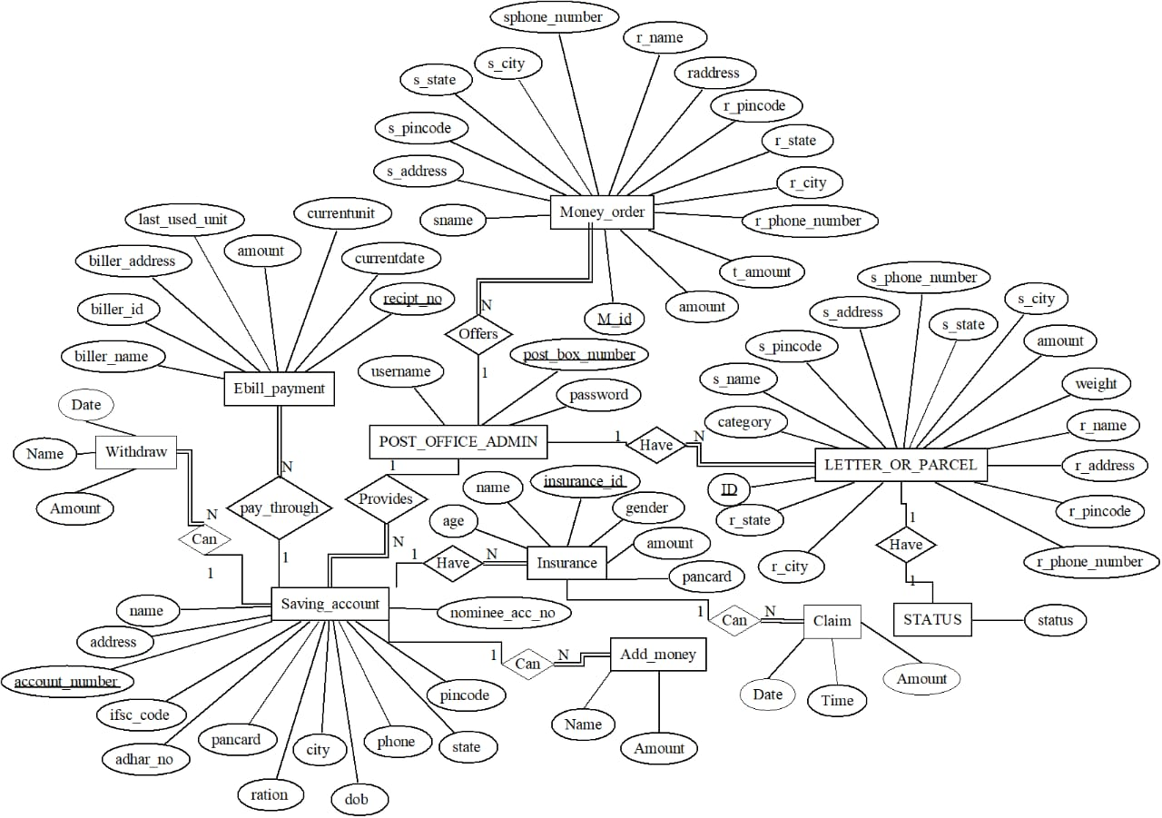 **fig 3.1**

**3.3 Table 1:Relationships in the relational schema**

|  |  |  |  |  |
| --- | --- | --- | --- | --- |
| **Entity 1** | **Entity 2** | **Relationships** | **Description** | **Cardinality ratio** |
| Post_office | Letter_or_Parcel | Have | 1 postoffice  maintain N  letter or parcel | 1:N |
| Post_office | Money_order | offers | 1 postoffice  offere  N money_order | 1:N |
| Post_office | Saving_account | provide | 1 postoffice  provide N  Saving account | 1:N |
| Letter_or_Parcel | Status | Have | 1 letter  or parcel have 1  status | 1:1 |
| Saving_account | Insurance | Have | 1 saving_account have N  Insurance | 1:N |
| Saving_account | ebill_payment | Pay_through | 1 saving_account  pays N  ebill_payment | 1:N |
| Saving_account | Withdraw | Can | 1 saving_account  Can have N  Withdraw | 1:N |
| Saving_account | Add_money | Can | 1 saving_account  Can have N  Add_money | 1:N |
| Insurance | Claim | Can | 1 Insurance  Can have N  Claim | 1:N |

**3.4 IMPLEMENTATION**

**Here we used MariaDB (MySQL) at the front end to store the data and information and Java for designing front end**

**3.5 TABLE CREATED**

create table addaccount(account_number varchar(20) primary key,name varchar(20),address varchar(20),ifsc_code varchar(20),adhar_no varchar(20),pancard varchar(20),ration varchar(20),DOB varchar(20),phone varchar(20),state varchar(20),city varchar(20),pincode varchar(20),nominee_acc_no varchar(30));

create table addmoney(name varchar(20), account_number references addaccount (account_number) on delete set null,amount varchar(20));

create table withdrawmoney(name varchar(20),account_number references on delete set null, date varchar(20),amount varchar(20));

create table createinsurance(account_number varchar(20),insurance_id varchar(20) primary key,name varchar(20),age varchar(20),gender varchar(20), amount varchar(20),pancard varchar(20),foreign key(account_number) references addaccont(account_number) on delete cascade);

create table insuranceclaim(insurance_id references createinsurance(insurance_id) on delete set null,time varchar(10),date varchar(20),amount varchar(20));

create table e_bill(biller_name varchar(20),biller_id varchar(20) ,biller_address varchar(40),last_used_unit varchar(20),currentunit varchar(20),amount varchar(20),current_date varchar(20),recipt_no varchar(20),primary key(recipt_no));

create table moneyorder( mid varchar(20),sname varchar(20),address varchar(20),pincode varchar(20),state varchar(20),city varchar(20),s_phone_number varchar(20),amount int,t_amount int,rname varchar(20),raddress varchar(20),rpincode varchar(20),rstate varchar(20),rcity varchar(20),rphone_number varchar(20));

create table lorp(category varchar(20),id varchar(20) primary key,s_name varchar(20),s_address varchar(20),s_pincode varchar(20),s_state varchar(20),s_city varchar(20),s_phone_number varchar(20),weight varchar(20),amount varchar(20),r_name varchar(20),r_address varchar(20),r_pincode varchar(20),r_state varchar(20),r_city varchar(20),r_phone_number varchar(20));

create table status(id varchar(20),status varchar(20),foreign key(id) references lorp(id) on delete cascade);

**3.6 CODE FOR TRIGGER**

delimiter //

create trigger amount

before insert on lorp

for each row

begin

if(new.weight>0&&new.weight<=10) then

set new.amount='10';

else if(new.weight>11&&new.weight<=20) then

set new.amount='15';

else if(new.weight>=21&&new.weight<=30) then

set new.amount='25';

else if(new.weight>=31&&new.weight<=40) then

set new.amount='35';

else if(new.weight>=41&&new.weight<=50) then

set new.amount='45';

else if(new.weight>=51&&new.weight<=60) then

set new.amount='60';

else if(new.weight>=61&&new.weight<=70) then

set new.amount='75';

else set new.amount='100';

end if;

end if;

end if;

end if;

end if;

end if;

end if;

end; //

delimiter ;

…………………………………….

**3.7 STORED PROCEDURE CODE**

DELIMITER$$

CREATE PROCEDURE getdeatils()

BEGIN

SELECT l.category, s.id, l.s_name,l.s_pincode,l.s_phone_number,l.r_name,l.r_address,

l.r_pincode, s.status FROM status S,lorp L where S.id=L.id;

END$$

DELIMITER ;

**3.6 JAVA CODE**

//:Open a connection

Class .forName(“com.mysql.jdbc.Driver”);

Connection conn = DriverManager.getConnection("jdbc:mysql://localhost:7777/postoffice", "root", "root");

System.out.println("Connected database successfully...");

**CHAPTER 4**

**TESTING AND ANALYSIS**

The purpose of testing is to discover errors. Testing is the process of trying to discover every conceivable fault or weakness in a work product. It provides a way to check the functionality of components, sub assemblies, assemblies and/or a finished product It is the process of exercising software with the intent of ensuring that the Software system meets its requirements and user expectations and does not fail in an unacceptable manner. There are various types of test. Each test type addresses a specific testing requirement.

System testing ensures that the entire integrated software system meets requirements. It tests a configuration to ensure known and predictable results. An example of system testing is the configuration oriented system integration test. System testing is based on process descriptions and flows, emphasizing pre-driven process links and integration points.

**4.1 UNIT TESTING**

Unit testing is undertaken when a module has been created and successfully reviewed. In order to test a single module, we need to provide a complete environment besides the module we would require

* The procedures belonging to other modules that the module under test calls. Non-local data structures that module accesses
* A procedure to call the functions of the module under test with appropriate parameters Unit testing was done on each and every module
* Testing admin login form-This form is used for log in of administrator of the system. In this we enter the username and password if both are correct administration page will open otherwise if any of data is wrong it will get redirected back to the login page and again ask for username and password.
* Admin- Admin can enter the additional soil detail that he encounters with.

**4.2 INTEGRATION TESTING**

In this type of testing we test various integration of the project module by providing the input. The primary objective is to test the module interfaces in order to ensure that no errors are occurring when one module invokes the other module.

We have checked all the modules by giving various type of inputs, when input does not match with stored data, it will be rejected by showing the error.

**CHAPTER 5**

**SCREENSHOTS**

**DATABASE**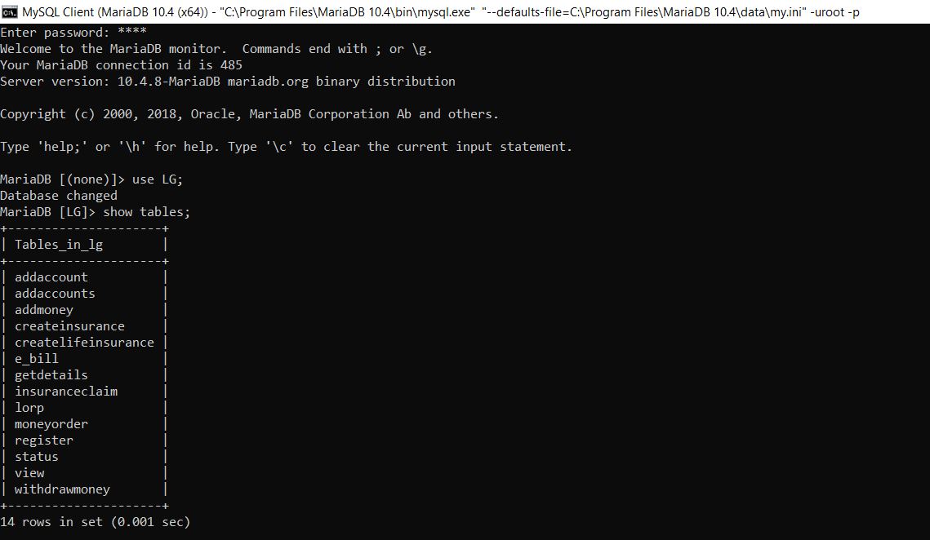

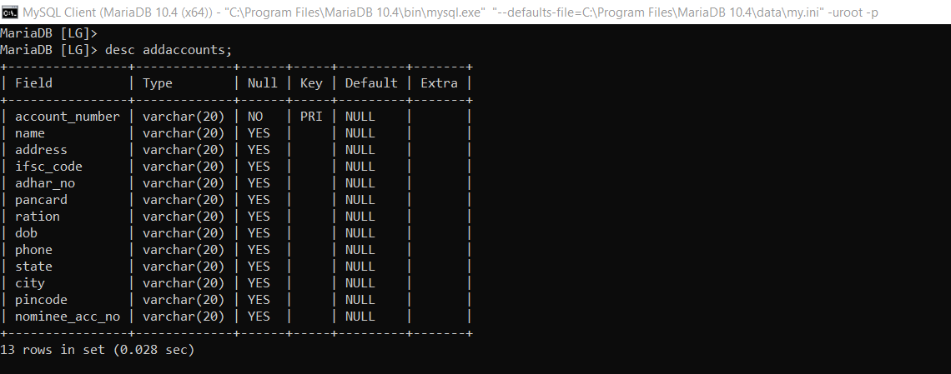

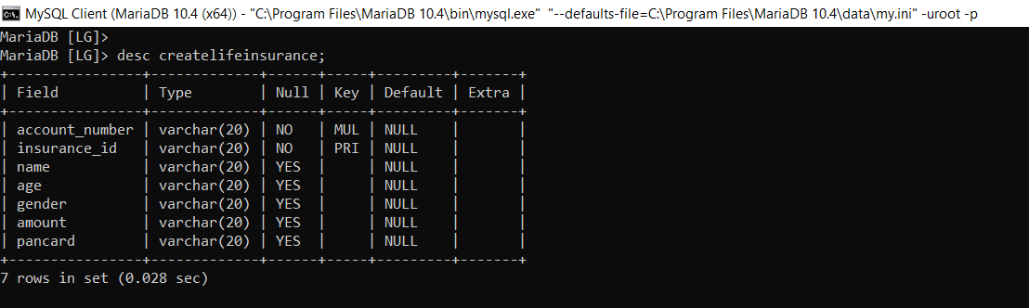

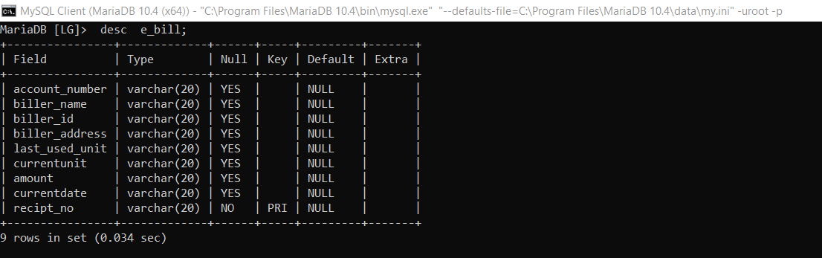

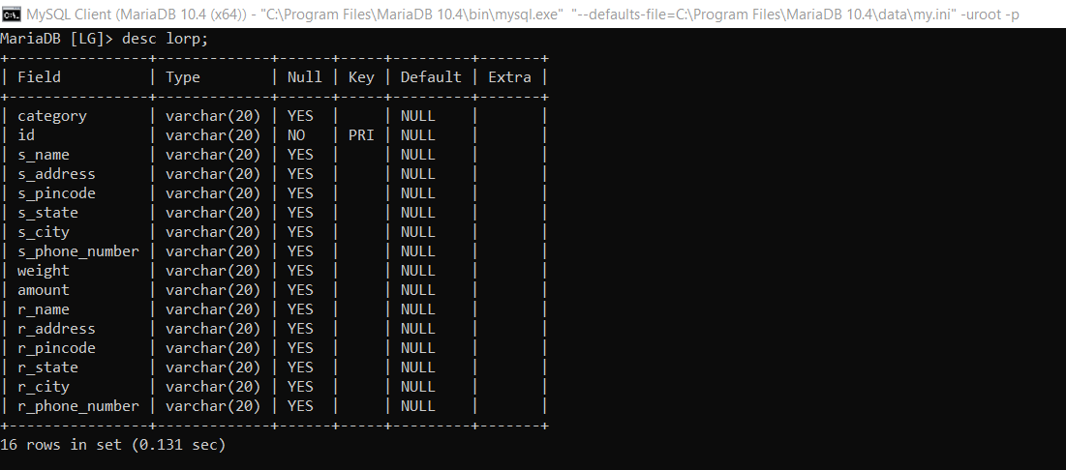

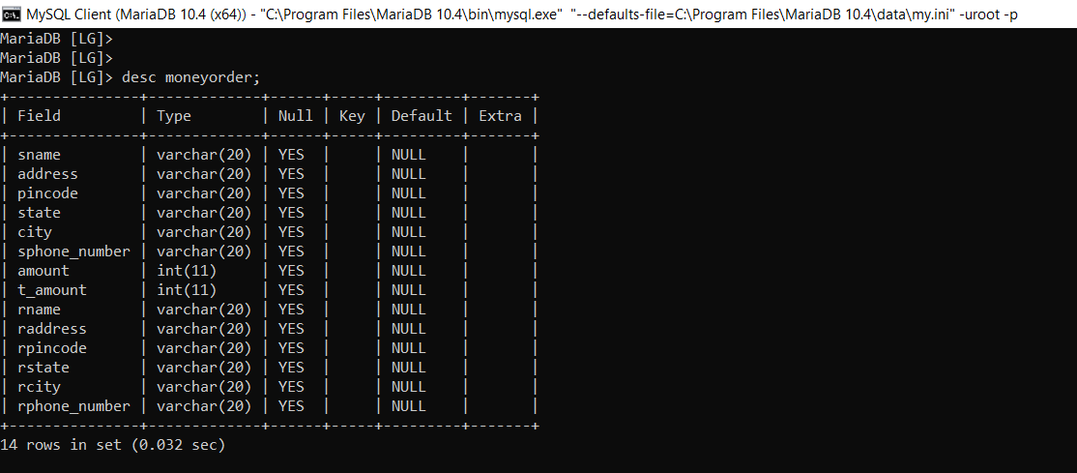

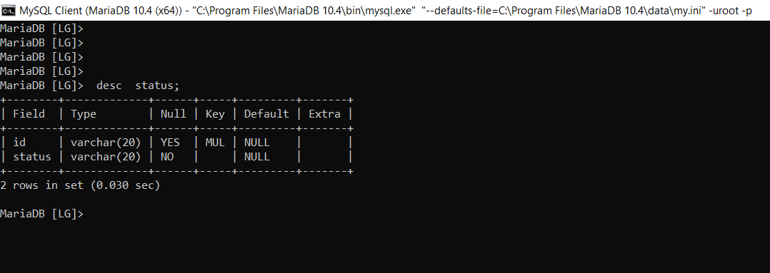

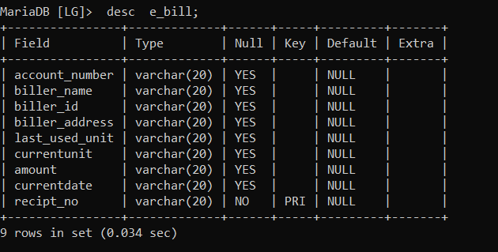

**Fig 5.1:DATABASE**

**LOGIN PAGE FOR ADMIN**

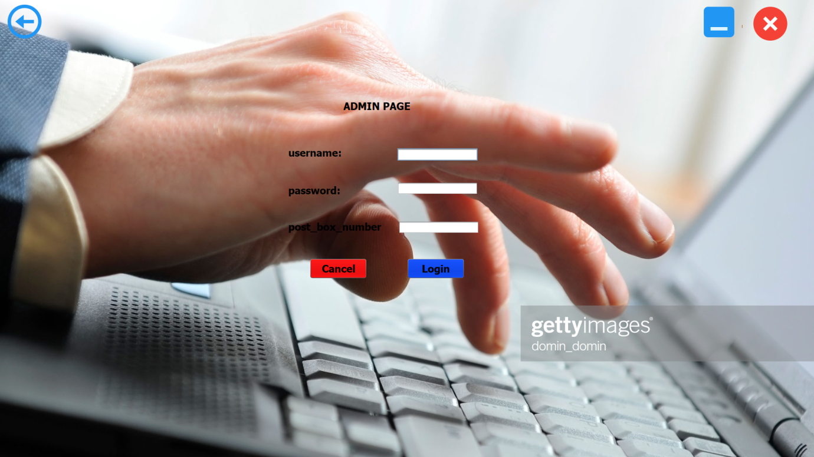

**Fig 5.2:LOGIN PAGE**

**FRONTPAGE** 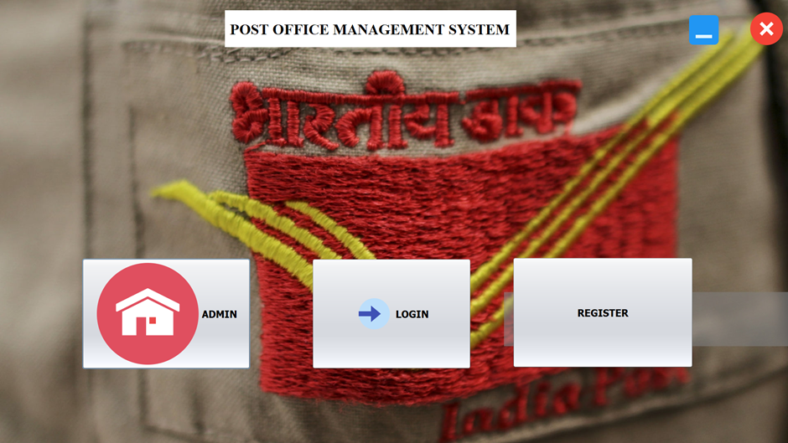

**Fig 5.3:FRONT PAGE**

**MENU** 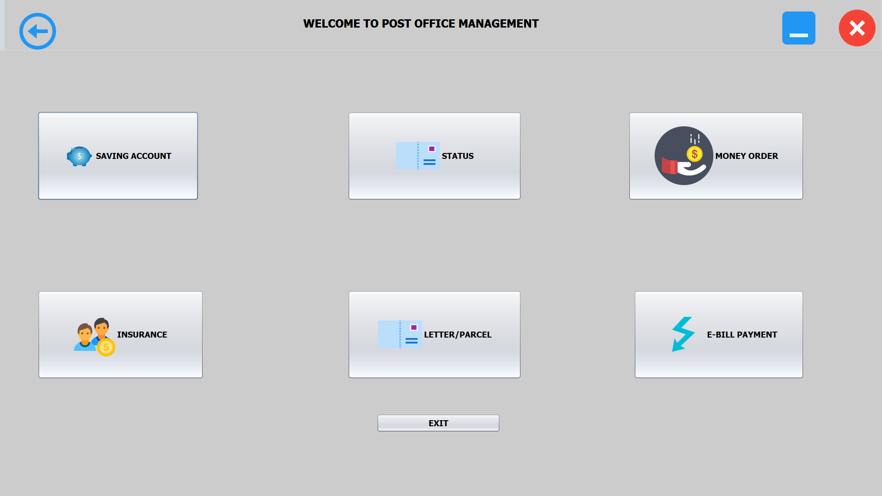

**Fig 5.4 MENU PAGE**

**CREATE ACCOUNT**

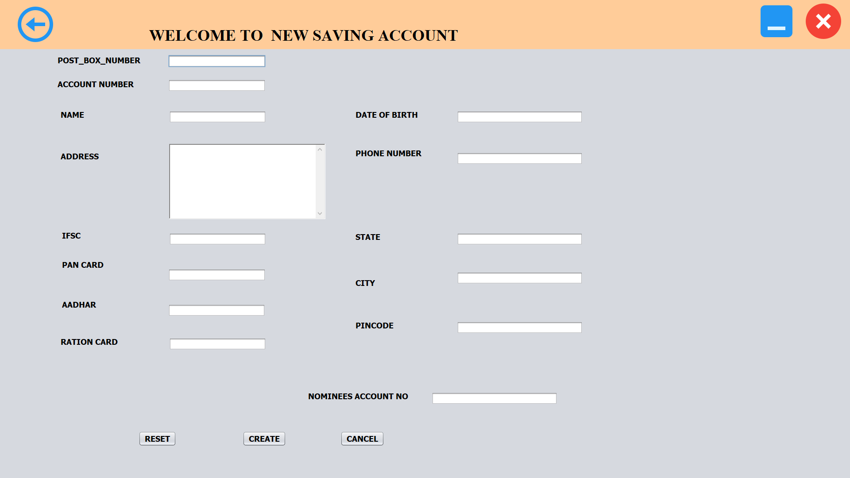

**Fig 5.5:CREATE ACCOUNT**

**MONEY ORDER**

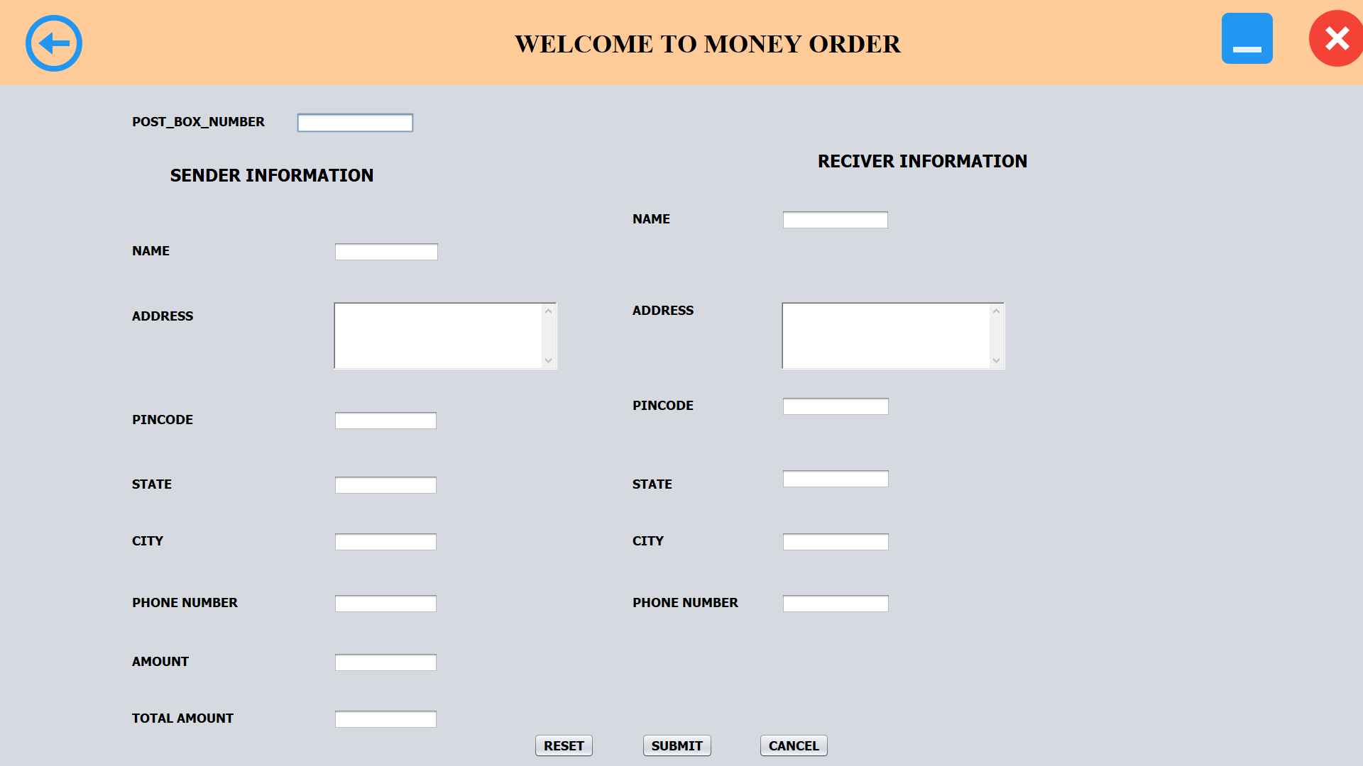

**Fig 5.6: MONEY ORDER**

**LIFE INSURANCE**

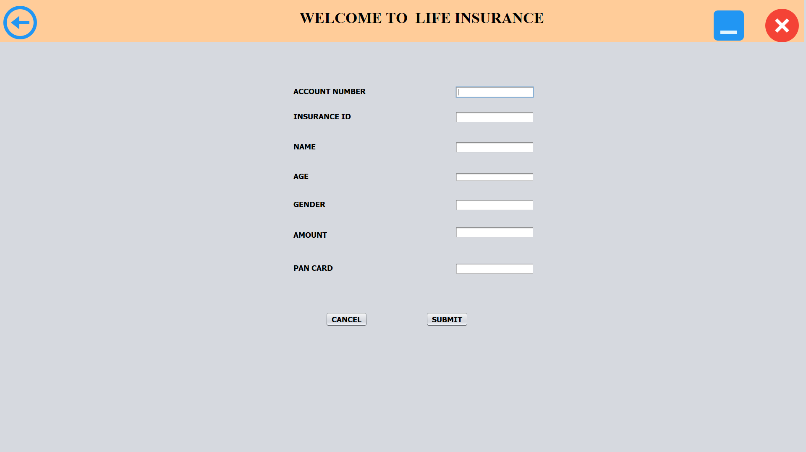

**Fig 5.7: LIFE INSURANCE**

**E_BILL**

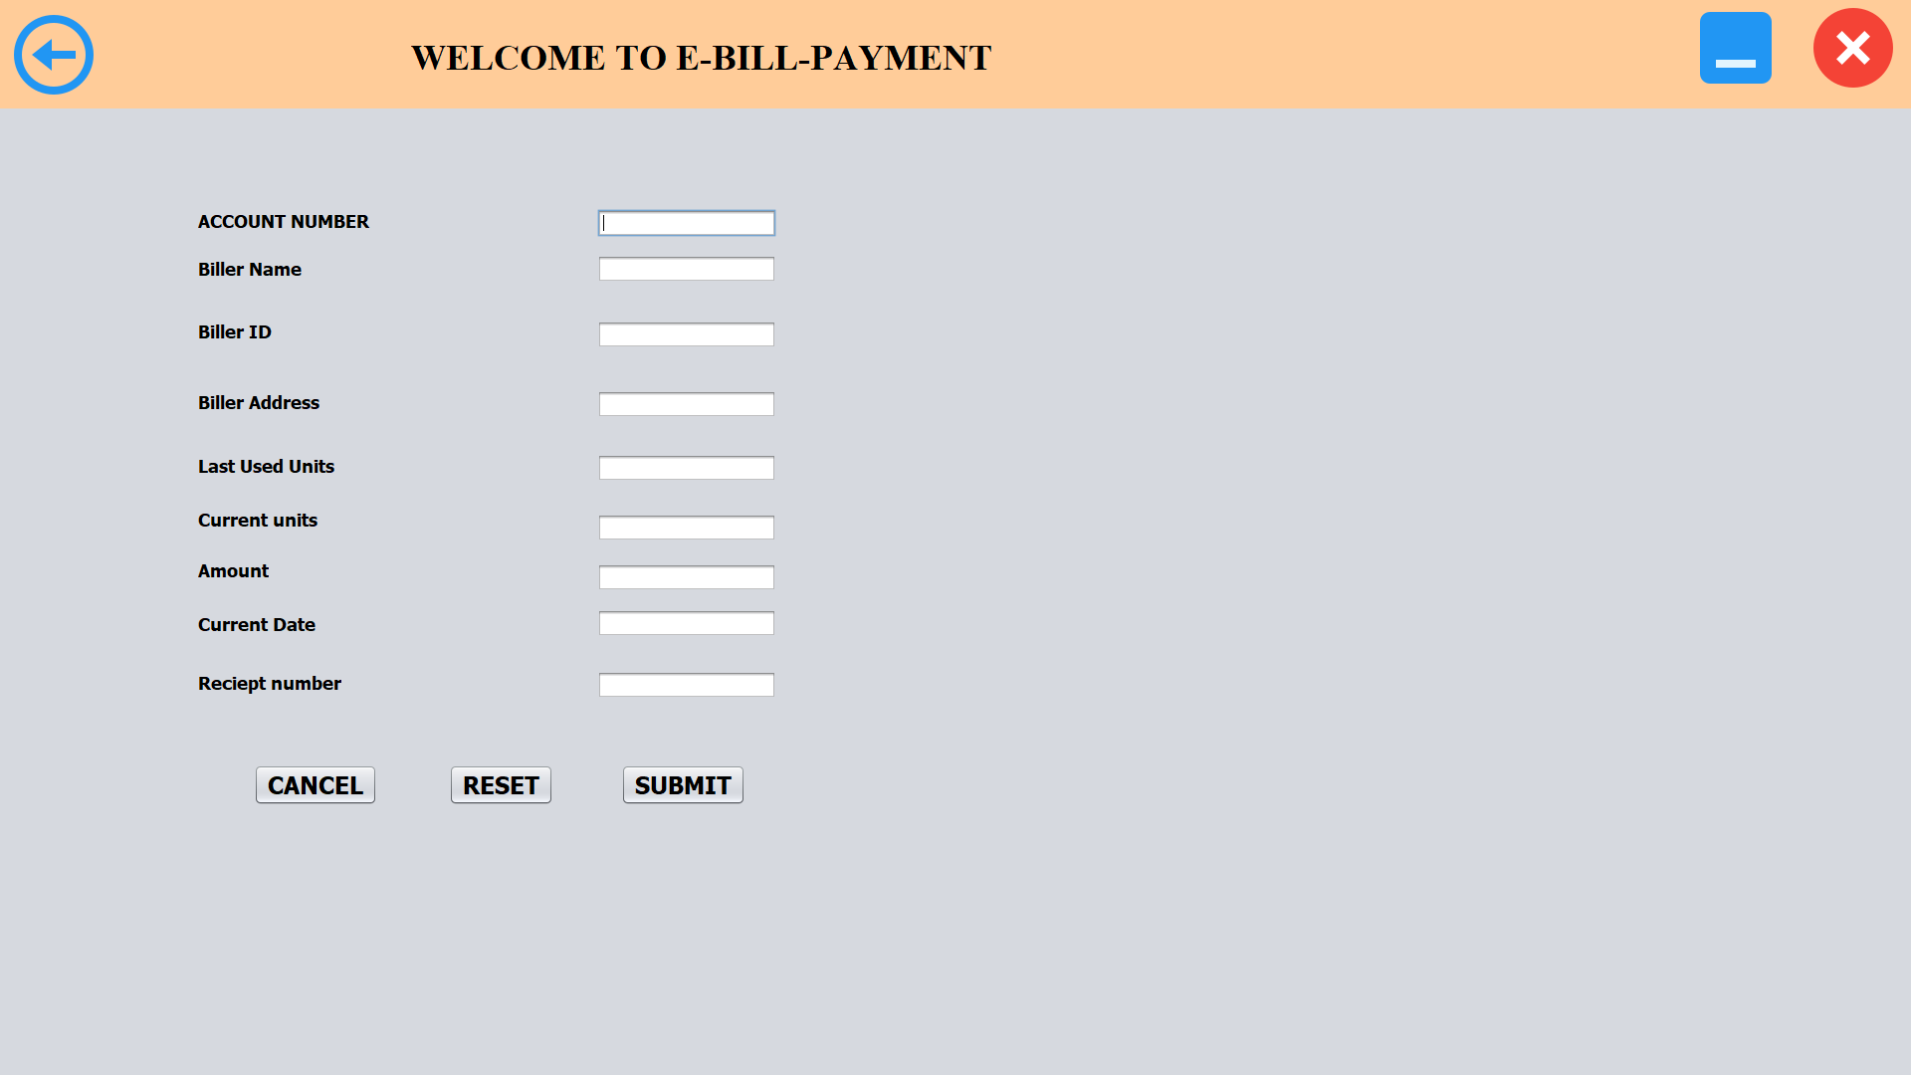

**Fig 5.8: E_BILL**

**LETTER OR PARCEL**

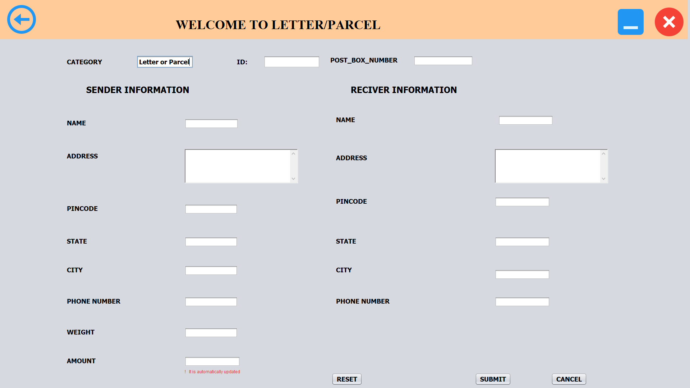

**Fig 5.9 LETTER OR PARCEL**

**VIEW OF TABLES**

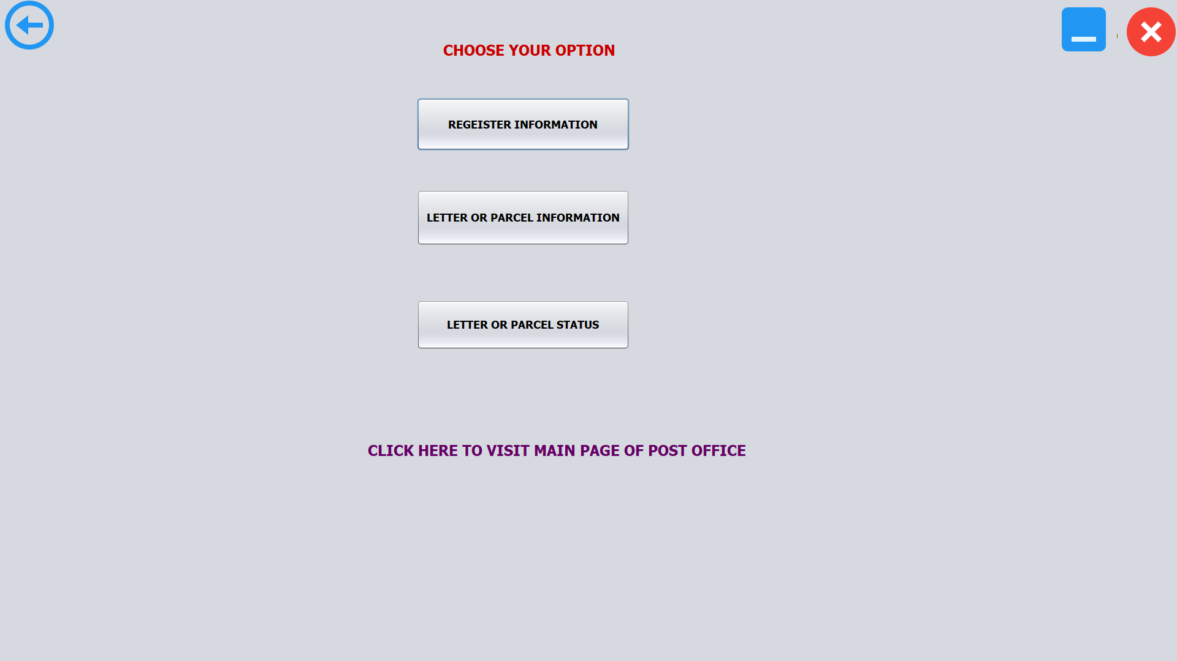

**Fig 5.10 VIEW**

**VIEW LETTER/PARCEL**

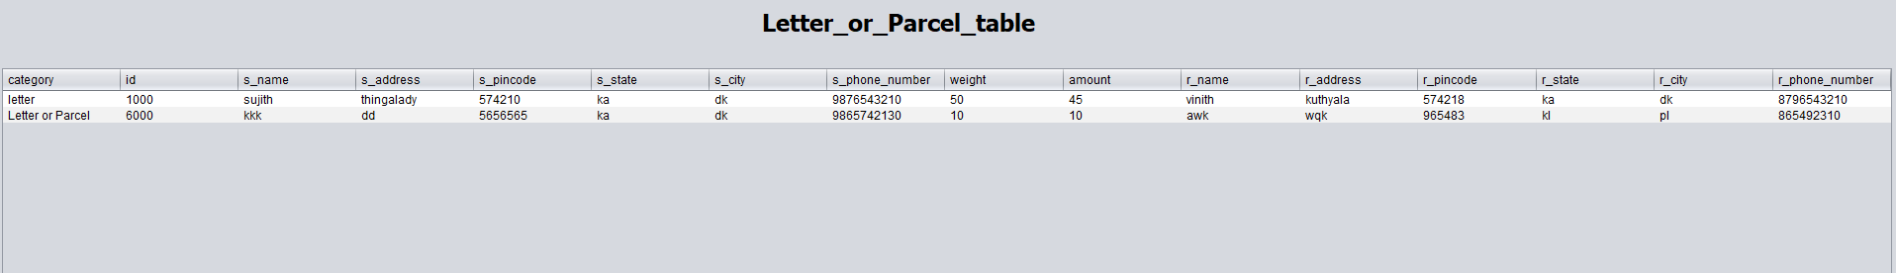

**Fig 5.11 VIEW LETTER/ PARCEL**

**REGISTER TABLE**

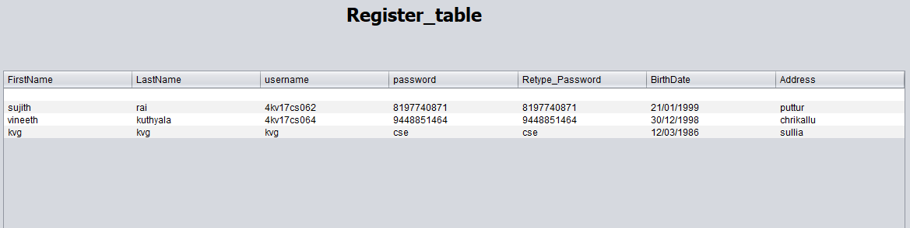

**Fig 5.12 REGISTER TABLE**

**STATUS OF LETTER/PARCEL**

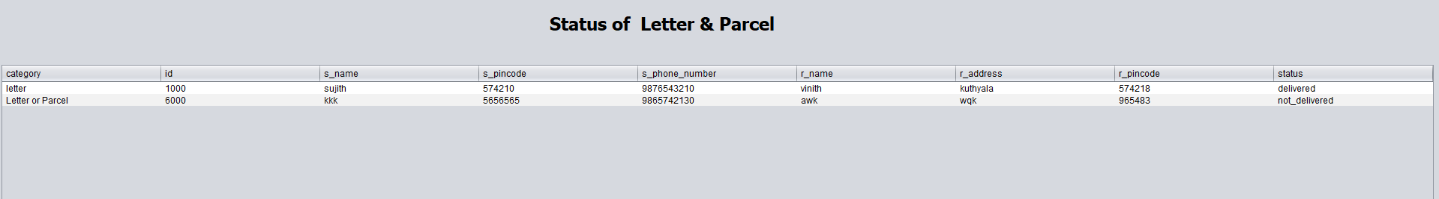

**Fig 5.13 DELIVERY STATUS(letter/parcel)**

**CHAPTER 6**

**CONCLUSION**

The system was mainly designed to reduce the manual work of updating and also make it easier for the employees. All the data’s of the accounts, money order, insurance details of letter or parcels are stored more efficiently and it is retrieved whenever it is required from database.

In this project we are mainly targeted on post office for the storing the data and we are given all the basic operations that that performs in the post office. Futher requirements and improvement can be easily done by designing codes. Improvement can be appended by changing the existing modules.

**REFERENCES**

[1] Remez Elmasri, Kant B. Navathe, The fundamentals of database systems of 7th edition , 2017, Pearson

[2] Ramakrishnan and Gehrke, Database management system, 3rd edition, 2014, McGraw Hill

[3] Herbert Schildt:Java The complete references,7th/9th edition ,Tata McGraw Hill, 2007.

[4] Jim Keogh:J2EE The complete reference,Mcgraw Hill,2007.